Characteristics of Effective Learning: Playing and exploring – children investigate and experience things and have a go; Active learning – children concentrate and keep trying if they encounter difficulties and enjoy achievements; Creating and thinking critically – children have and develop their own ideas, make links between ideas, and develop strategies for doing things. In addition, the prime area of learning PSE, CL and PD underpin and are an integral part of all areas of learning.
Personal, Social & Emotional Development Educational Programme: Children’s personal, social and emotional development (PSED) is crucial for children to lead healthy and happy lives, and is fundamental to their cognitive
development. Underpinning their personal development are the important attachments that shape their social world. Strong, warm and supportive relationships with adults enable children
to learn how to understand their own feelings and those of others. Children should be supported to manage emotions, develop a positive sense of self, set themselves simple goals, have
confidence in their own abilities, to persist and wait for what they want and direct attention as necessary. Through adult modelling and guidance, they will learn how to look after their
bodies, including healthy eating, and manage personal needs independently. Through supported interaction with other children, they learn how to make good friendships, co-operate and
resolve conflicts peaceably. These attributes will provide a secure platform from which children can achieve at school and in later life.
Intent: We use the Jigsaw scheme of work through which to deliver our PSHE curriculum. It provides a structured programme of personal development to nurture the ‘whole child’ and increase learning capacity, underpinned by mindfulness philosophy and practice. Each lesson offers opportunities for children’s spiritual, moral, social and cultural (SMSC) development, and this is clearly mapped and balanced across each year group. Every lesson is structured to practise and enhance the five skills associated with the emotional literacy (self-awareness, social skills, empathy, motivation and managing feelings). At we believe that these opportunities are vital for children’s development, their understanding of themselves and others and in increasing their capacity to learn.
Learning Overview | We will explore our own feelings and how we can manage them when we feel sad, happy or angry thinking about kind hands. | We will look at how being different is a good thing and explore what being a kind friend means. | We will think about our dreams and goals and understand the importance of perseverance. | We will give thought to looking after ourselves - being healthy, exercising, resting and hygiene. We will look closely on keeping ourselves safe with other people we don’t know. | We will think about relationships with friends and families and identify some of the jobs I do to help. | We look at our changing bodies and how we have grown from babies. We will think about our transition into Class 2 and reflect back on memories from Class 1.
Term | Autumn 1 | Autumn 2 | Spring 1 | Spring 2 | Summer 1 | Summer 2
PSHE  We revisit knowledge and skills throughout the year  Jigsaw  Evidence on Tapestry | Select and use resources in the new classroom environment  Getting used to new rules and routines  Exploring feelings  Building relationships with peers and adults  Using the toilet independently | Continue to develop friendships  Exploring feelings  Increased following of rules and routines | Show independence in selecting and using the resources  Identify a range of feelings and how others may feel  Begin to take on challenges and show perseverance | Begin to regulate their behaviour  Show independence in managing their needs  Apply personalised strategies to return to a state of calm  Begin to show resilience in the face of challenge | Express and moderate feelings  See themselves as valuable individuals  Finding solutions to conflicts  Explain reasons for rules  Being able to curb impulsive behaviours  Being able to ignore distractions  Thinking before acting | Manage own basic hygiene  Working co-operatively and taking turns with others with no help  Show understanding of others feelings and perspectives  Give focussed attention
 | Being Me in My World  I can help others to feel welcome.  I am beginning to recognise and manage my own feelings  I understand why it is good to have kind and gentle hands  I am beginning to understand what responsible means | Celebrating Differences  I can talk about what I am good at.  I understand that being different makes us all special  I know ways that we are different and the same  I can tell you how to be a kind friend  I can tell you why my home is special to me  I know ways to stand up for myself. | Dreams and Goals  I understand that if I persevere I can tackle challenges  I can tell you a time that I didn’t give up  I can set a goal and work towards it  I can use kind words to encourage people  I know what it means to feel proud of myself. | Healthy Me  I understand that I need to exercise to keep my body healthy  I understand that moving and resting are good for my body  I know which foods are healthy and not healthy  I know how to help myself go to sleep and why it is good for me  I can wash my hands thoroughly and I know why it is important to stay healthy  I know what a stranger is and how to keep safe if a stranger approaches me  I know why oral hygiene is important for growing and healthy teeth | Relationships  I can identify some of the jobs I do in my family and how I feel like I belong  I know how to make friends to stop myself from feeling lonely  I think of ways to solve problems and stay friends  I can start to understand the impact of unkind words  I can use Calm Me time to manage my feelings  I know how to be a good friend | Changing Me  I can name parts of the body  I can tell you some things I can do and foods I can eat to be healthy  I understand that we all grow from babies to adults  I express how I feel about moving to Year 1  I can talk about my worries and/or the things I am looking forward to about being in Year 1  I can share my memories of the best bits of Reception
 | Linked stories  Dogger  Hands are not for hitting | Linked stories  Elmer  Barry the Fish with Fingers  The Family Book  The Dog and the Dolphin | Linked stories  Love Monster  Don’t Worry  Hugless Douglas | Linked stories  Never Talk to Strangers  Not Everyone is Nice | Linked stories  Mable and Me  George and Martha | Linked stories  I wonder why kangaroos have pouches  Huge Bag of Worries  Look inside your body
Key vocabulary | help, feelings, kind, gentle, responsible | different, special, same, kind, friend, home | persevere, challenge, goal, kind, encourage, proud | exercise, healthy, not healthy, movement, rest, sleep, wash, stranger, safe | jobs, family, belong, friends, lonely, problems, unkind, calm, feelings | body, healthy, grow, babies, adults, moving on, worries, memories
Our Curriculum Goal | To become an Independent Individual who can follow the Golden Rules, set simple goals and persevere to achieve them, select resources, manage their own personal needs and know how to stay fit and healthy.  To become a Fantastic Friend who can be kind, caring and helpful, show empathy and respect to others, work and play co-operatively whilst considering others’ ideas and feelings
ELG  (End of the year only) | Self-Regulation  - Show an understanding of their own feelings and those of others, and begin to regulate their behaviour accordingly;  - Set and work towards simple goals, being able to wait for what they want and control their immediate impulses when appropriate;  - Give focused attention to what the teacher says, responding appropriately even when engaged in activity, and show an ability to follow instructions involving several ideas or actions.  Managing Self  - Be confident to try new activities and show independence, resilience and perseverance in the face of challenge;  - Explain the reasons for rules, know right from wrong and try to behave accordingly;  - Manage their own basic hygiene and personal needs, including dressing, going to the toilet and understanding the importance of healthy food choices.  Building Relationships  - Work and play cooperatively and take turns with others;  - Form positive attachments to adults and friendships with peers;  - Show sensitivity to their own and to others’ needs.
During KS1, children will learn | During KS1, children will learn  - Relationship education  - Sex education  - Health education

Our PSHE journey through the year
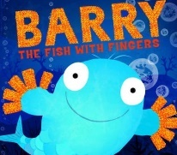
To understand that being different makes us all special.
To know ways that we are different and the same.

To understand what being responsible means.
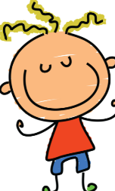
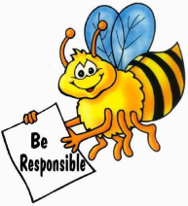
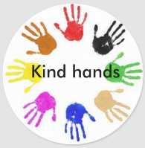
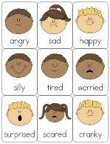
To know ways to stand up for myself.
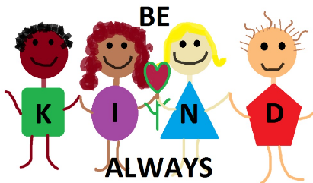
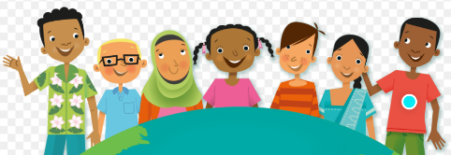

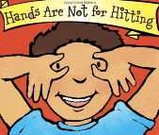
To begin to recognise and manage my own feelings.

To understand why it is good to have kind and gentle hands.

To wash my hands thoroughly and I know why it is important to stay healthy

To understand how to be a kind friend

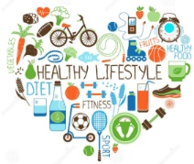
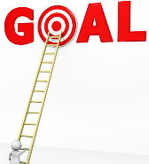
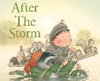
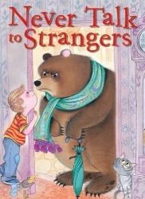
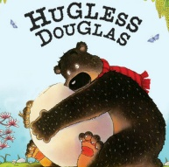
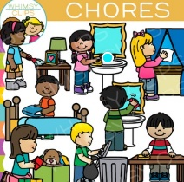
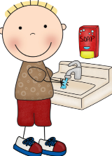
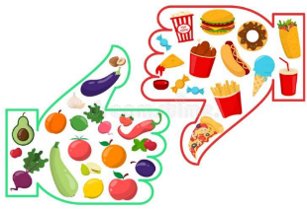
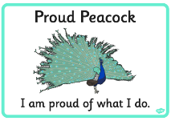
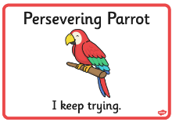
To identify some of the jobs I do in my family.

To understand that I need to exercise to keep my body healthy
To understand that moving and resting are good for my body
To know which foods are healthy and not healthy

To understand that if I persevere I can tackle challenges.
To tell you a time that I didn’t give up.

To know what a stranger is and how to keep safe if a stranger approaches.
To set a goal and work towards it.
To know what it means to feel proud of myself.

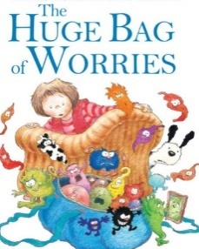

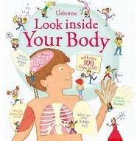
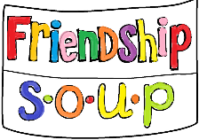
To understand that we all grow from babies to adults.

To start to understand the impact of unkind words.

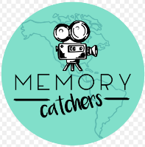
To talk about the things I am looking forward to about being in Year 1.

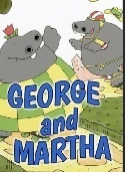
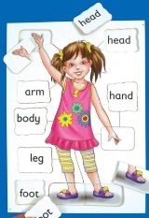
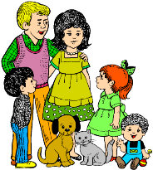
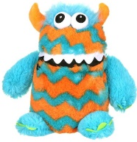
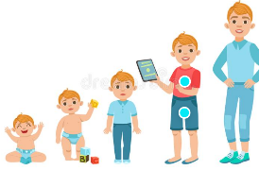
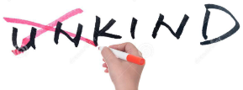

To share my memories of the best bits of Reception.
To know how to be a good friend.

To name parts of the body
To tell you some things I can do and foods I can eat to be healthy.

To talk about my worries.

To know how I feel like I belong.

