Characteristics of Effective Learning: Playing and exploring – children investigate and experience things and have a go; Active learning – children concentrate and keep trying if they encounter difficulties and enjoy achievements; Creating and thinking critically – children have and develop their own ideas, make links between ideas, and develop strategies for doing things. In addition, the prime area of learning PSE, CL and PD underpin and are an integral part of all areas of learning
Expressive Arts & Design Educational Programme: The development of children’s artistic and cultural awareness supports their imagination and creativity. It is important that children have
regular opportunities to engage with the arts, enabling them to explore and play with a wide range of media and materials. The quality and variety of what children see, hear and participate
in is crucial for developing their understanding, self-expression, vocabulary and ability to communicate through the arts. The frequency, repetition and depth of their experiences are
fundamental to their progress in interpreting and appreciating what they hear, respond to and observe.
Intent: At Kimbolton our DT curriculum is built on children’s enthusiasm for creating and constructing. In taught and independent work, children develop the skills to design and make
products fit for purpose. Through a practical approach, children will evaluate and discover how and why things work in daily life.
Themes | A1 - I wonder what’s marvellous about me  A2 - I wonder what we celebrate |  | Sp1 – I wonder what’s above and beyond the clouds  Sp2 – I wonder what’s out there |  | S1 – I wonder where this journey will take us  S2 - I wonder what happened in the past
Learning Overview | We will make bread rolls like The Little Red Hen. We will ensure that we follow correct food hygiene procedures when handling and making food. We will also make bird feeders for the outside area. |  | We will design and make a rocket and join it using a variety of joining materials, including split pins. We will consider how we might adapt our rockets if we repeated the activity. We also make some Easter nests! |  | We will have a go at making and tasting traditional food from other countries. We will create boats. We will have a go at making a simple stitch patchwork.
Term | Autumn 1 | Autumn 2 | Spring 1 | Spring 2 | Summer 1 | Summer 2
DT  Evidence in Floor Book  We revisit knowledge and skills throughout the year | Cooking & Nutrition  To work safely and hygienically.  To know and use some non-statutory measures e.g. spoons/cups.  To use some techniques e.g. mix, spread, knead | Mechanisms  To know about materials, tools and techniques, experimenting with form and function  To know how items can be combined and changed | Structures  To draw a plan  To select appropriate resources  To use different techniques for joining materials, such as adhesive tape and different sorts of glue or string  To know what I like and dislike about creation  To know how to adapt work | Cooking & Nutrition  To represent and construct own ideas, thoughts and feelings through design  To know what they want to make | Structures  To know about materials, thinking about uses and purposes  To discuss work as it progresses | Textiles  To name some tools needed to work the materials e.g. needle  To use a range of materials and tools with care and precision
DT Sticky Skills & Knowledge  Skills & Knowledge children need to know by the end of every half-term. | I can work safely and hygienically. | I know how items can be combined and changed. | I know what I like and dislike about creation  I know how to adapt work | I know I can use my own ideas to make things | I know that working as a team can sometimes be better than working alone  I know that some materials are better for building with than others. | I can use a range of tools and materials.
Key vocabulary | ingredients, recipe, weigh, measure, cup, safe, hygiene, spoons, mix, spread, knead, shape, form, function, combine, change |  | design, create, make, cut, join, decorate, material, purpose, user, construct, dislike, like, improve, adapt |  | uses, purpose, progress, team | tools, care, precision, needle, fabric, thread, stitch
Our Curriculum Goal | To become a Dynamic Designer who can choose and safely use the resources they need to make their creations, talk about what they have made and how they have made it.
ELG  (End of the year only) | Creating with Materials  - Safely use and explore a variety of materials, tools and techniques, experimenting with colour, design, texture, form and function;  - Share their creations, explaining the process they have used;  - Make use of props and materials when role playing characters in narratives and stories.
During KS1, children will learn | During KS1, children will learn to  Design  - Design purposeful, functional, appealing products for themselves and other users based on design criteria  - Generate, develop, model and communicate their ideas through talking, drawing, templates, mock-ups and, where appropriate, information and communication technology  Make  - Select from and use a range of tools and equipment to perform practical tasks [for example, cutting, shaping, joining and finishing]  - Select from and use a wide range of materials and components, including construction materials, textiles and ingredients, according to their characteristics  Evaluate  - Explore and evaluate a range of existing products  - Evaluate their ideas and products against design criteria  Technical knowledge  - Build structures, exploring how they can be made stronger, stiffer and more stable  Explore and use mechanisms [for example, levers, sliders, wheels and axles], in their products.

Cooking and Nutrition  Understand and apply the principles of nutrition and learn how to cook | Design: Developing, Planning and Communicating Ideas  Understand context, uses and purpose  Generate, develop, model and communicate ideas | Make  Work with tools, equipment, materials and components to make quality products | Evaluate  Evaluate processes and products | Technical Knowledge  Develop technical expertise and knowledge
Begin to work safely and hygienically  Weigh using non-statutory measures e.g. spoons/cups.  Begin to use some techniques e.g. mix, spread, knead | Use what I have learnt about materials, thinking about uses and purposes  Think about and discuss what I want to make  Discuss my work as it progresses | Explore a variety of materials, tools and techniques, experimenting with design, form and function  Represent and construct my own ideas, thoughts and feelings through design  Explore different techniques for joining materials, such as how to use adhesive tape and different sorts of glue  Use a range of materials and tools with care and precision | Describe what I like and dislike about my creation  Adapt work where necessary | Select appropriate resources  Make decisions on how items can be combined and changed  Name of tools needed to work the materials

Our DT journey through the year

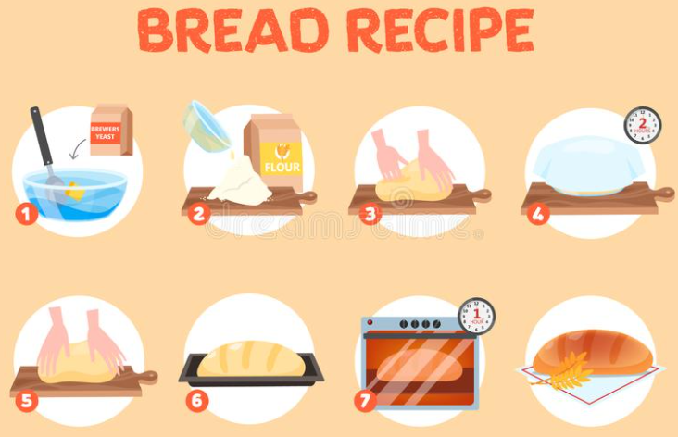
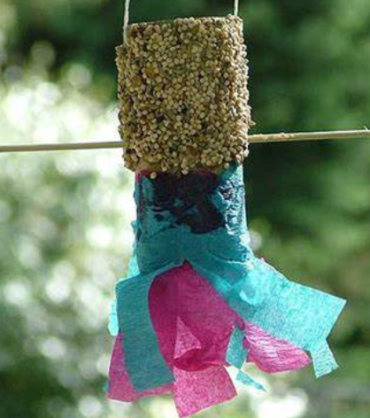

To make a birdfeeder for our outdoor area

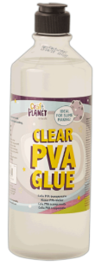
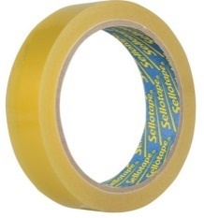

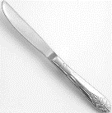

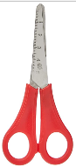
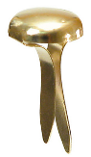
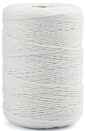
To work safely and hygienically.
To know and use some non-statutory measures e.g. spoons/cups.
To use some techniques e.g. mix, spread, knead
To know about materials, tools and techniques, experimenting with form and function
To know how items can be combined and changed

To use a range of cutting tools
To use a variety of joining equipment

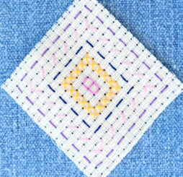
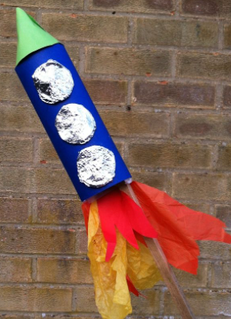
To know about materials, thinking about uses and purposes
To know how to select appropriate resources
To use different techniques for joining materials, such as adhesive tape and different sorts of glue or string
To represent and construct own ideas, thoughts and feelings through design
To know what I like and dislike about creation
To know how to adapt my work

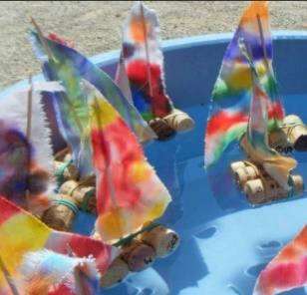
To discuss work as it progresses
To know what they want to make
To use a range of materials and tools with care and precision
To name some tools needed to work the materials e.g. needle

