Kimbolton St. James’ C of E Primary School
Key Drivers in Phonics

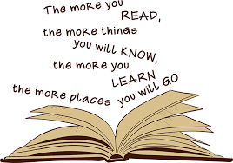

At Kimbolton St James’ C of E Primary School we strive to ensure that all children become successful, fluent readers by the end of Key Stage One and believe this is achievable through a combination of strong, high quality, discrete phonics teaching combined with a whole language approach that helps instil a lifelong love of reading and literature. This approach is in alignment with our belief that we first ‘learn to read’ and then ‘read to learn’.
Our phonics curriculum and teaching equips pupils with the ability to segment and blend sounds so that their decoding skills provide a sound foundation for reading, writing and spelling.
We want to ensure that by the end of Key Stage One the children know the 44 phonemes within the English language and can recognise the corresponding graphemes within words in order to help them to read. We also aim to provide children with strategies to identify and decode tricky words known as ‘red words’.
We want to enable children to use their phonic awareness in all subjects so that they can use their reading skills to develop their understanding and knowledge across all curriculum areas.
As pupils progress, their growing phonic and ‘red word’ knowledge will give them the necessary skills to enable them to become fluent readers with a love of reading and a thirst to acquire knowledge and understanding of the world around them.

