Appraisal Policy & Procedure for Schools

Table of contents
1. INTRODUCTION 3
2. SCOPE 3
2.1 2020 COVID-19 update 3
3. PRINCIPLES 4
3.1. Fairness 4
3.2. Feedback to employees 4
3.3. Role of the line manager / appraiser. 5
3.4. Role of the employee / appraisee 5
3.5. Annual Appraisal Discussion 5
3.6. Training 6
4. APPRAISAL PERIOD 6
5. APPOINTING APPRAISERS 7
6. SETTING OBJECTIVES 7
7. REVIEWING PERFORMANCE 9
8. ANNUAL ASSESSMENT 12
9. CONFIDENTIALITY 14
10. EQUALITY & CONSISTENCY 14
11. COMPLIANCE 14
12. IMPACT ON THE SCHOOL’S KEY PRIORITIES 14
13. TRAINING AND AWARENESS REQUIREMENTS 15
14. MONITORING 15
15. REVIEW 15
APPENDIX 1 – DEFINITIONS & RESPONSIBILITIES 17
APPENDIX 2 –MAKING DATA WORK 19
APPENDIX 3 – HASH CAREER STAGE EXPECTATIONS 20
APPENDIX 4 – LAYERED OBJECTIVES 27

1. INTRODUCTION
Governing Bodies are required to have appropriate appraisal arrangements in place which allow schools to manage and review individual employee performance annually.
This procedure is designed in accordance with the Education (Schools Teachers’ Appraisal) (England) Regulations 2012, and sets out the principles that apply to teachers and support staff in all maintained schools. The new regulations provide LAs and schools with more freedom to design arrangements in accordance with the needs of the school. This policy sets out the minimum standards required by the regulations, which can be adapted by individual schools.
Schools should apply a common sense approach and are advised to review the DfE document “Making Data Work”.
Click here for link to 'Making Data Work'

2. SCOPE
This policy and procedure applies to all categories of schools and Pupil Referral Units.
Where Herefordshire Council is not the legal employer (Voluntary Aided Church Schools, Trust Schools or Academy Schools), schools may chose to adopt a different appraisal procedure but must have regard to the Education (School Teachers’ Appraisal) (England) Regulations 2012.
The appraisal policy applies to all Teachers employed on permanent contracts of employment and those employed on fixed term contracts lasting one school term or more.
This appraisal policy applies to Support Staff in schools.

2.1 2020 COVID-19 update
Maintained schools must continue to adhere to the School Teachers’ Pay and Conditions Document (STPCD), which includes the requirement to ensure that all pay progression for teachers is linked to performance management. We would expect schools to use their discretion and take pragmatic steps to adapt performance management and appraisal arrangements to take account of the current circumstances. Schools must ensure that teachers are not penalised during the appraisal process or in respect of any subsequent pay progression decisions as a result of the decision to restrict pupil attendance at schools, such as where this has had an impact on the ability of the teacher to meet fully their objectives.
Click here for full guidance, page 28

3. PRINCIPLES

3.1. Fairness
- Appraisals represent an opportunity to assess employee performance against specific objectives and provide a mechanism to discuss development.
- It is important that appraisals are conducted fairly and objectively.
- No employee will be treated unfavourably on the grounds of the protected characteristics of age, disability, gender reassignment, marriage and civil partnership, pregnancy and maternity, race, religion and belief, sex or sexual orientation, or any other grounds.
- Decisions on teachers’ pay progression must only be related to performance appraisals and cannot be made based on funding
- The Government’s expectation is that good classroom teachers should expect to reach the maximum of the main pay range within 5 years.

3.2. Feedback to employees
- An integral part of the appraisal process is providing regular feedback to employees on their performance.
- Regular feedback ensures that employees understand what is expected of them, and how they are performing against the requirements of the role and specific set objectives.
- Regular feedback should be given through the normal management process for example regular 1:1s, team meetings etc.
- Arrangements for giving feedback will be determined by the school.
- Feedback should be sourced from a wide range of sources including other colleagues, and subordinates (where applicable).
- Feedback should not just be given at the annual appraisal stage; employees need to have regular feedback throughout the year.
- Where it is identified that there is a potential performance issue a programme of support should be arranged through the appraisal process,with the individual prior to any escalation to formal capability procedures.
- The relevant body should manage the appraisal and pay determination process so that there are no surprises at the end of the appraisal cycle - throughout the appraisal cycle both teacher and appraiser should understand what objectives are in place, the evidence that will be used to assess performance against objectives and the criteria for successful performance review.
- There is a clear expectation in the STPCD that good performance should lead to pay progression and the school’s pay policy should define what constitutes good performance in the context of the school. In circumstances where a teacher does not receive pay progression, an important part of the feedback will be to outline the evidence that was taken into account to support this decision, and to explain how any development issues can be addressed.

3.3. Role of the line manager / appraiser.
- In most circumstances the individual’s line manager will be the person reviewing and monitoring ongoing performance, holding regular 1:1s and conducting the annual appraisal discussion.
- The line manager / appraiser will be responsible for providing support including coaching and mentoring to ensure that employees know what is required of them and how to achieve performance standards and include, as appropriate a discussion on appropriate CPD.
- Where the person conducting the appraisal is not the individual’s line manager the appraiser must have some direct responsibility for the performance of the individual and they must be suitability trained in the appraisal process.
- The person conducting the appraisal must be in a more senior post within the school; it is not appropriate for the appraiser to be of the same level or in a lesser post than the person being appraised.
- The line manager / appraiser will ensure that an annual performance appraisal for all staff is undertaken once a year.
- It is recommended that a mid-year review is also undertaken.
- The line manager/appraiser will make a pay recommendation where appropriate.

This role is undertaken by the Governing Body for Headteachers (see para 7)

3.4. Role of the employee / appraisee
- Every employee should ensure that they take responsibility for their own professional development.
- The appraisee will ensure that they strive to meet and exceed objectives, and will ensure that continuous professional development is planned and evidenced.
- Staff should meet with their Headteacher or line manager to discuss their salary progression aspirations and development needs.
- The appraisee should keep a record of achievement and development activities throughout the year, in preparation for the annual performance appraisal.

3.5. Annual Appraisal Discussion
Every employee in the school will have an annual appraisal discussion, in line with the school’s appraisal cycle and the dates published for holding annual appraisal discussions. Please see school specific guidance.
The annual appraisal discussion will include the following:
- Review of the individual’s performance over the last academic year, including a review against the objectives set at the beginning of the appraisal period.
- Agreeing objectives for the next appraisal period in line with school priorities, and for teaching staff, in line with teacher standards and the school’s priorities for teaching and learning for the coming year.
- A discussion regarding professional development and training activities.
- A written report detailing the appraisal discussion will be issued to the employee for signature, within 5 working days.
- The annual appraisal will be confidential and employee appraisal documentation will be placed on the employee’s file for 6 years.

3.6. Training
The Governing Body and Headteacher are responsible for ensuring that managers within the school who have responsibility for undertaking appraisals are sufficiently trained, and supported in order to conduct appraisals and performance management in line with the annual appraisal period.

4. APPRAISAL PERIOD
- The appraisal period will run for twelve months from 1st September until 31st August.
- The annual appraisal cycle will be determined by the relevant school and dates for
review for Teaching and Support staff will be clearly outlined at the beginning of the appraisal cycle. Please see school’s specific guidance.
- Teachers who wish to apply for progression, or in exceptional circumstances accelerated progression, must do so by 31st October in the academic year in which the application relates.
- Any award will be backdated to 1st September. Please see the ‘Teacher Performance Related Pay Policy (HR007 (SCH)) for further information.
- Teachers who are employed on a fixed term contract of less than one year will have their performance managed in accordance with the principles underpinning this policy. The length of the period will be determined by the duration of their contract and an individual teacher’s objectives should take account of the length of contract
- Where a Teacher ceases employment other than at the end of the appraisal period, as detailed in 3.1, the appraisal period ends with the last day of employment.
- Every employee will be appraised at least once every 12 months. Unless there are exceptional circumstances the annual appraisals will normally be completed by 31st October. It is recommended that every employee has a mid-year review appraisal discussion.
- The annual appraisal discussion will normally be held in July at the end of the academic year (but no later than early September prior to the next appraisal cycle).
- Objectives for each teacher will be set before, or as soon as practicable after, the start of each appraisal period.
- The school may choose to hold appraisal discussions for support staff at a different time to the timeframe for teaching staff. This will be determined and agreed by the Governing Body in conjunction with the Headteacher.
- The timeframe for holding annual appraisal discussions will be communicated to all staff particularly where the timeframes vary for teaching and support staff.

5. APPOINTING APPRAISERS
Headteacher
The Headteacher will be appraised by the Governing Body, supported by a suitably skilled and / or experienced external advisor who has been appointed by the Governing Body for that purpose.
The headteacher’s objectives will be set by the governance board after consultation with the external adviser. The task of appraising the Headteacher, including the setting of objectives, will be delegated to a sub-group appraisal panel consisting of three members of the Governing Body.
Where a Headteacher is of the opinion that any of the governors appointed by the Governing Body is unsuitable to act as his/her appraiser, s/he may submit a written request for that governor to be replaced, stating the reasons for the request.
Teachers
The choice of appraiser is for the Headteacher. Where teachers have an objection to the Headteacher’s choice, their concerns should be raised formally and will be carefully considered and, if appropriate, an alternative appraiser will be offered. All appraisers appointed by the Headteacher will be qualified teachers and will have current or recent teaching experience.
Appraisers will be trained in appraisal procedures, and reviewing performance and will be conversant will the School’s Appraisal policy and procedure.
Where it becomes apparent that the appraiser appointed by the Headteacher will be absent for the majority of the appraisal cycle, the Headteacher may perform those duties herself/himself or delegate those duties to another teacher who has undertaken the relevant training on appraisal procedures for the duration of that absence.
If the Headteacher appoints an appraiser who is not the teacher’s line manager, the appraiser to whom she/he delegates those duties will have an appropriate position in the staffing structure, together with the necessary background knowledge, skills and training to undertake the role.
Support staff
Support staff members will normally be appraised by their direct line manager. This will be determined by the Headteacher.

6. SETTING OBJECTIVES
See appendix 3 for examples of layered objectives linked to the school improvement plan
Teaching staff
- The Headteacher’s objectives will be set by the Governing Body after consultation with the external advisor.
- Objectives for each teacher will be set before the start of the appraisal period or as soon as practicable after, the start of each appraisal period.
- The objectives set for each teacher will be specific, measurable, achievable, realistic and time-bound (SMARTID) and will be appropriate to the teacher’s role and level of experience.
- The appraiser and teacher will seek to agree the objectives but if that is not possible, the appraiser will determine the objectives.
- Objectives may be revised if circumstances change.
- The objectives for teachers will be linked to the relevant Teacher standards and in line with level of experience and relevant stage of career and (following the introduction of teacher performance related pay) salary aspirations.
- Objectives will link to school priorities for teaching and learning as identified in the School’s improvement plan.
- The objectives set for each teacher will, if achieved, contribute to the School’s plans for improving the School’s educational provision and performance and improving the education of pupils at the School.
- It is recommended and accepted practice within Herefordshire that teachers have three objectives.
- The criteria for the objectives should be made clear to the employee so they are aware of what success should look like, i.e

‘highly competent’
performance which is not only good but also good enough to provide coaching and mentoring to other teachers, give advice to them and demonstrate to them effective teaching practice and how to make a wider contribution to the work of the school, in order to help them meet the relevant standards and develop their teaching practice
‘substantial’
of real importance, validity or value to the school; play a critical role in the life of the school; provide a role model for teaching and learning; make a distinctive contribution to the raising of pupil standards; take advantage of appropriate opportunities for professional development and use the outcomes effectively to improve pupils’ learning;
‘sustained’
maintained continuously over a long period
The appraiser will take into account the effects of an individual’s circumstances, including any disability, when agreeing objectives. For example, this might include a reasonable adjustment to allow an individual slightly longer to complete a task that might otherwise be the case. When staff return from a period of extended absence, objectives may be adjusted to allow them to readjust to their working environment.
Before, or as soon as is practicable after the start of each appraisal period, each teacher will be informed of the standards against which their performance in that appraisal period will be assessed. Teachers will be assessed against the appropriate set of standards contained in the document “Teachers’ Standards” published in May 2012. The Headteacher or Governing Body (as appropriate) will need to consider whether certain teachers with specific responsibilities should be assessed against other sets of standards published by the Secretary of State or other body that are relevant to them. For QTLS holders, this may include the overarching professional standards for teachers in the lifelong learning sector, held by the Learning and Skills Improvement Service
Teachers who do not wish to progress through the pay ranges will continue to be set objectives so that they continue to develop as a professional teacher.
Objectives will be moderated across the school to ensure that they are consistent between teachers with similar experience and levels of responsibility.
The teacher will receive as soon as practicable following the end of each appraisal period – and have the opportunity to comment on – an appraisal report (in practice the report could be produced using online performance management systems, which can help to reduce workload.
Appendix 1 sets out the ‘Teaching Standards and Herefordshire Association of Secondary Headteacher (HASH) Agreed Career Stage Expectations for information, and possible use or adaptation by individual schools.
Support staff
Support staff objectives will be set by their line manager in line with requirements of the post, the level of experience in the current role, the grade, and will be in line with the needs of the school.

7. REVIEWING PERFORMANCE
Observation – Teaching
    - The School believes that observation of classroom practice and other responsibilities is important both as a way of assessing teachers’ performance in order to identify any particular strengths and areas for development they may have and of gaining useful information which can inform school improvement more generally.
    - All observations will be approached in a supportive and positive manner.
- There will usually be a limit of three observations for all purposes and the total time occupied by all observations will usually not exceed three hours per year. The focus and timing of observations should be agreed in the performance management/appraisal planning statement.
- Where a teacher gives cause for concern additional observations may take place as detailed in the feedback and support section.
    - Classroom observation will be carried out by those with QTS
    - Verbal feedback will be provided at least by the end of the next school day and written feedback within 5 working days, unless circumstances make this impossible.
    - In addition to formal observation, Headteachers or other leaders with responsibility for teaching standards may ‘drop in’ in order to evaluate standards of teaching and to check that high standards of professional performance are established and maintained. (See Section below)
    - The length and frequency of ‘drop in’ observations will vary depending on specific circumstances and will be determined by the school.
    - Teachers (including the Headteacher) who have responsibilities outside the classroom should also expect to have their performance of those responsibilities observed and assessed.

Learning Walks/Drop In’s

Learning walks are structured walks through classrooms in order to provide evidence about pupil learning, pupil progress and areas for school development. They are intended to be constructive and developmental and to support a whole school or department wide improvement activity.
Staff will be advised when learning walks are due to take place and visits to individual classrooms would usually be no longer than 15 minutes in duration.
Information gathered in a learning walk would not be used to evaluate the performance of a teacher either for appraisal or capability purposes.
When concerns are raised during a learning walk, the person conducting the learning walk will have a professional conversation with the teacher to discuss the issue which may result in support being initiated.

Development and support
Teaching staff
    - Appraisal is a supportive process which will be used to inform continuing professional development.
    - The school wishes to encourage a culture in which all teachers take responsibility for improving their teaching through appropriate professional development.
    - Professional development will be linked to school improvement priorities and to the ongoing professional development needs and priorities of individual teachers.
    - The school’s/academy’s CPD programme will be informed by the training and development needs identified as part of the appraisal process.
    - The Governing Body will ensure in the budget planning that, as far as possible, resources are made available in the school budget for appropriate training, and support agreed for appraisees, maintaining access on an equitable basis.
Support staff
    - Support staff will be given development opportunities in line with the requirements of their job role and the needs of the school.

Feedback
Teaching Staff
- Teachers will receive constructive feedback on their performance throughout the year through regular 1:1s, and as soon as practicable after observation has taken place or other evidence has come to light (see paragraph 9.13).
- There should be no surprises at the appraisal meeting as employees should have been updated and received feedback throughout the year.
- Feedback will highlight particular areas of strength as well as any areas that the teacher needs to focus on in line with individual objectives and teacher standards.
- Where it is identified that there is a potential performance issue and the Headteacher / appraiser has concerns about any aspects of the teacher’s performance, the appraiser will meet the teacher formally to:

- give clear feedback and evidence to the teacher about the nature and seriousness of the concerns; (NB clear written evidence should back up the discussion; i.e. lesson observations, appraiser observation where teacher standards have not been met, pupil data and assessment information etc)
- give the teacher the opportunity to comment and discuss the concerns;
- agree any support (e.g. coaching, mentoring, structured observations), that will be provided to help address those specific concerns;
- agree targets for improvement (in the form of a personal development plan) and set an informal support and review period;
- make clear how, and by when the appraiser will review progress, explain the implications and process if no or insufficient improvement is made.

- Following the discussion, a performance improvement plan should be developed clearly outlining the standards of performance expected, with a clear indication of targets to be achieved and the timeframe for the review period.
- The review period should be long enough to allow sufficient time for the individual to improve their performance.
- During the support and review period, performance should be regularly reviewed and the individual given feedback on their performance and on the targets set.
- This will provide an opportunity to discuss ongoing support, and any further coaching or support that may be required.
- At the end of the review period, if the appraiser is satisfied that the teacher has made, or is making sufficient improvement, the appraisal process will continue as normal, with any remaining issues continuing to be addressed though that process.

Support staff
    - Support staff will receive feedback ongoing from their direct line manager, through regular meetings.
    - There should be no surprises at the appraisal meeting as employees should be updated and receive feedback throughout the year.
    - Where a performance issue is identified the same process for improvement will be followed as detailed in the section below, but will be appropriate to the level held within the school.
    - The support given through the monitoring period will be appropriate to the performance issue to be improved, and designed to achieve that purpose. This includes coaching, mentoring, job shadowing, and other development opportunities.
    - Targets set for improvement will be SMARTID, and the support staff member will be clear on the standards expected.
    - The informal review period will be long enough to in order to achieve improvement to the required level of performance.

Transition to Capability Procedure (Teaching Staff)

If at the end of the informal review period the teacher has not achieved the targets set and the appraiser is not satisfied with progress, the teacher will be notified in writing that the appraisal system will no longer apply and that their performance will be managed under the capability procedure. Please refer to HR001 (SCH) Teacher Capability Procedure for all Categories of School.
Transition to Managing Performance (Support staff)

If at the end of the informal review period the support staff member has not achieved the targets set and the appraiser is not satisfied with progress, they will be notified in writing that the appraisal system will no longer apply and that their performance will be managed under the Managing Performance Policy and Procedure (HR006).

8. ANNUAL ASSESSMENT
Teaching Staff
  - Each teacher's performance will be formally assessed in respect of each appraisal period.
  - In assessing the performance of the headteacher, the Governing Body must consult the external advisor.
  - This assessment is the end point to the annual appraisal process, but performance and development priorities will be reviewed and addressed on a regular basis throughout the year in interim meetings which take place (eg once a term).
  - Achievements should be rated in accordance with the following definitions:

‘highly competent’
performance which is not only good but also good enough to provide coaching and mentoring to other teachers, give advice to them and demonstrate to them effective teaching practice and how to make a wider contribution to the work of the school, in order to help them meet the relevant standards and develop their teaching practice

‘substantial’
of real importance, validity or value to the school; play a critical role in the life of the school; provide a role model for teaching and learning; make a distinctive contribution to the raising of pupil standards; take advantage of appropriate opportunities for professional development and use the outcomes effectively to improve pupils’ learning;
‘sustained’
maintained continuously over a long period
  - The teacher will receive as soon as practicable following the end of each appraisal period, and have the opportunity to comment in writing on, a written appraisal report. The school will determine dates by which Teachers and the Headteacher will receive their written appraisal reports. The appraisal report will include:

- details of the teacher’s objectives for the appraisal period in question;
- an assessment of the teacher’s performance of their role and responsibilities against their objectives and the relevant standards;
- an assessment of the teacher’s professional development needs and identification of any action that should be taken to address them;
- a recommendation on pay where that is relevant (NB – pay recommendations need to be made by 31 December for Headteachers and by 31 October for other teachers);

The assessment of performance and of professional development needs will inform the planning process for the following appraisal period.
Support staff
  - Support staff members will be appraised at least once per year.
  - The annual appraisal discussion will include a:
- review of the previous year recognising key achievements and contributions to the school.
- discussion of the employee’s own assessment of their performance
- review of the objectives set and agreement of objectives for the next appraisal period.
- discussion regarding development needs.

- The appraisal discussion is an opportunity for an open discussion between the manager (appraiser) and the employee. It should be supportive, and positive in nature.
- It is not appropriate to raise performance issues during the appraisal discussion if these have not been raised with the individual before.
- A support staff performance appraisal form will be completed and will be signed by the manager and employee.
- If there is any disagreement with the judgement the employee should be given the opportunity to record their comments.
- A copy of the written record should be given to the employee and a copy kept on personal file.

9. CONFIDENTIALITY
The appraisal process including regular 1:1s and the annual appraisal discussion should be kept confidential by the line manager / appraiser and the employee.
The Governing Body and Headteacher will ensure that all written appraisal records are retained in a secure place on the employee’s for six years and then destroyed.

EQUALITY & CONSISTENCY
  - All appraisal documentation will be kept confidential and the contents of the discussion will remain confidential between the line manager / appraiser and the employee, and other relevant senior member(s) of staff (as agreed with the appraisee). With the agreement of the appraisee, documentation may also be provided to the appropriate trade union representative.
  - The Headteacher will be responsible for the quality assurance of the appraisal process and will ensure that there is equality and consistency at all stages of the process.
  - Headteachers need to ensure moderation of initial recommendations with a view to putting individual pay progression recommendations to governing body for agreement and so as to account to them overall for the effective operation of links between pay and performance.
  - Where a school has more than 1 appraiser (other than the headteacher) the headteacher may be the moderator.
  - Schools should refer to the DfE Guidance Document “Implementing your School’s Approach to Pay” 2019 page 15 for further information regarding the Equality Act 2010.
  - Schools should also refer to the DfE Document “Making Data Work” Click here for link to 'Making Data Work'

11. COMPLIANCE
  - Failure to follow this procedure may impact on good employee relations and the reputation of the School and Governing Body as a good employer. In addition, it may result in the Governing Body breaching employment legislation, incurring financial penalties and / or damage to its reputation.
  - Headteachers who fail to manage in accordance with this policy will be investigated and this may lead to formal action under the Teacher Capability Policy and Procedure or Disciplinary Policy and Procedure.

12. IMPACT ON THE SCHOOL’S KEY PRIORITIES
The policy provides clear statements about headteacher and employee responsibilities to ensure that capability issues are raised and dealt with in a timely manner. This procedure supports schools in delivering excellent teaching and learning and enables the Governing Body to effectively meet its key school priorities.

TRAINING AND AWARENESS REQUIREMENTS
Headteachers and employees will be informed about this policy and procedure via communication channels such as school newsletters, schools online and the extranet.

14. MONITORING
  - Human Resources Services is responsible for ensuring the review of this policy and procedure.
  - The Governing Body is responsible for adopting and implementing this policy and procedure.
- The Governing Body and Headteacher will monitor the operation and effectiveness of the school’s appraisal arrangements.
- HR Services and the Learning & Achievement Team will be notified of any cases where it is concluded that the policy was breached. The notification will indicate whether there are any changes or improvements required to the policies, procedure, training, support or any other aspect of the school’s approach to grievance matters.

15. REVIEW
This document will be reviewed annually.
Document Classification
Consultation Log
Date sent for consultation | Consultees
Herefordshire Council

Ceri Morgan – Assistant Director Education Development & Skills

Schools/Academies

Julie Rees – Headteacher – Ledbury Primary School
Lisa Appleton –- Headteacher -Barrs Court Special School
Sue Gaston - Headteacher – Fairfield High School
Tim Mamak – Headteacher – Leominster Primary School
Tracey Kneale – Executive Headteacher – Marlbrook Primary School, St Martins Primary School, Little Dewchurch Primary School

Steve Kendrick – Headteacher – Ashfield Park Primary School
Martin Henton – Headteacher – Bishop Of Hereford Bluecoat School
Kristian Phillips –Assistant Headteacher –John Kyrle High School

Hoople Ltd (HR Services)
Julie Davies - HR Manager - Schools
Julie Bridgewater- Senior HR Advisor - Schools

Trade Unions
Chris Lewandowski (NASUWT)
Paul Deneen (NEU)
Noel Glover (NAHT)
Carol Rushton (ASCL)
Steven Baker (NEU)
Dick Colligan (VOICE)

APPENDIX 1 – DEFINITIONS & RESPONSIBILITIES
The meaning of some key words and phrases, for the purposes of this policy, are explained below:
Work Colleague. A current employee from the individual’s workplace or by mutual agreement, a current employee from another workplace.
Headteacher. The person responsible for leading and managing the school, and has delegated powers to ensure capability issues are appropriately managed. References to the Headteacher shall include any nominated Deputy Headteacher acting on his / her behalf. Headteachers are responsible for making employees aware of this policy. Headteachers are responsible for ensuring that appraisal discussions are carried out effectively, and for monitoring adherence to the appraisal policy and procedure. Headteachers are responsible for ensuring that managers are trained in order to carry out appraisals
Appraiser. The person or panel who sets and monitors objectives and undertakes the appraisal.
Trade Union representative. Lay or permanent official of the Trade Union to which the employee belongs, who has been reasonably certified in writing by their union as having experience of, or having received training in, acting as a worker’s companion at capability hearings.
Working days. Any designated term-time or Teacher Education Training Day or any other contractual working day, but excluding the day of any capability meeting and the day on which the notification of the meeting is sent to the employee.
LA. Local Authority
SMARTID. Principles of setting objectives. Specific, Measurable, Achievable, Realistic, Time-bound, Impactful and Differentiated.
QTLS. Qualified Teacher Learning and Skills.
QTS. Qualified Teacher Status.
CPD. Continuous Professional Development
Employees are responsible for participating in appraisal review of their own development and progress towards agreed objectives. All employees should ensure that relevant documentation is completed with the line manager/reviewer.
Governing Bodies are responsible for establishing arrangements for performance management and appraisal. Governing bodies are responsible for ensuring that the appraisal policy and procedure is embedded within the school and all employees have an annual appraisal discussion.
Human Resources Services is responsible for providing timely and appropriate advice and support to the Headteacher or Governing Body as required. They are not responsible for making decisions in relation to this procedure; these remain the responsibility of the Headteacher and Governing Body. Human Resources Services is accountable for the advice they give.
Learning & Achievement Team is responsible for providing support and guidance to Headteachers and Governing Bodies on identifying, monitoring and resolving teacher capability issues.

APPENDIX 2 –MAKING DATA WORK
Head teachers and Line Managers should be mindful of the document Making Data Work, here , when setting objectives. Particular attention should be given to the following extract from page 17 of the guidance. Implementing your schools approach to pay should also be reviewed and was updated in light of Making Data Work in 2019.
Teacher performance management
Teachers should have goals that are within their control, that are closely tied to genuinely actionable behaviours, and that are aspirational yet achievable. School and trust leaders should also consider the burden of gathering evidence for performance management, and whether their approach is proportionate for all staff, including trainees and newly qualified teachers.

Individual performance of pupils in tests is due to a range of factors and this should be recognised. Assessments are designed to evaluate, measure and report the progress and attainment of pupils, rather than evaluate the performance of teachers. Trying to hold teachers to account for assessments that they typically administer themselves undermines effective assessment and risks unduly distorting curriculum and classroom practice. The performance of a single exam class should also not be used as a principal measure of teaching quality in a performance management system, not least because it can distort the focus of teachers away from other classes. The exam performance of a class depends on many factors, most of which are outside the control of the person who happens to have them in their final year. This is why pay progression should never be dependent on quantitative assessment metrics, such as test outcomes.

While data based on commercially produced predictions can play a helpful role in informing professional conversations about pupil achievement and the work of teachers, these systems produce ranges of grade estimates and inaccurate grade targets, and should therefore not be treated as accurate targets. Ofsted have clarified that inspectors do not expect school and trust leaders to set teacher performance targets based on commercially produced predictions of pupil achievement, or any other dataset, from which they would then hold teachers to account.

Current practice in using pupil attainment data in teacher performance management systems is often poor. Research demonstrates that using quantitative metrics to judge teacher performance is difficult since few of the practices that we can straightforwardly codify and measure are highly correlated with teacher quality. Pupil assessment scores, grades in lesson observations, and scores following book scrutiny are all quite poor proxies for whether or not somebody is teaching well.

Suitable teacher performance goals include those related to their classroom instructional practices, their contributions to the development of school curriculum and the relationships they uphold with pupils, colleagues and parents. If teachers are held to account for things that are largely outside their own control, such as a pupil’s test performance or progress based on flight paths, it is not only unfair, but induces high levels of stress and is likely to lead to burnout and ultimately attrition from the profession.

APPENDIX 3 – HASH CAREER STAGE EXPECTATIONS
Name:________________________________________________ Date:_________________ Completed by Appraisee / Appraiser (delete as appropriate)
Teaching Standards and HASH Agreed Career Stage Expectations
Each of the standards is underpinned by further detail, which is linked below to Professional: Practice, Outcomes, Relationships, Professional Development and Conduct. The Professional standards for post-threshold teachers, excellent teachers and ASTs are incorporated in the CSE indicated as P1 to P10 and given in full overleaf.
Preamble
Teachers make the education of their students their first concern, and are accountable for achieving the highest possible standards in work and conduct. Teachers act with honesty and integrity; have strong subject knowledge; keep their knowledge and skills as teachers up-to-date and are self-critical; forge positive professional relationships; and work with parents in the best interests of their students
Part 1 Teaching
A teacher must:
1.1. Set high expectations, which inspire, motivate and challenge students
1.2. Promote good progress and outcomes by students
1.3. Demonstrate good subject and curriculum knowledge
1.4. Plan and teach well structured lessons
1.5. Adapt teaching to respond to the strengths and needs of all students
  - . Make accurate and productive use of assessment
1.7 Manage behaviour effectively to ensure a good and safe learning environment
1.8 Fulfill wider professional responsibilities
Part 2 Personal and Professional Conduct
The following statements define the behaviour and attitudes, which set the required standard for conduct throughout a teacher’s career
2.1. Teachers uphold public trust in the profession and maintain high standards of ethics and behaviour, within and outside school,
  - Teachers must have a proper and professional regard for the ethos, policies and practice of the school in which they teach, and maintain high standards in their own attendance and punctuality
  - Teachers must have an understanding of, and always act within, the statutory frameworks which set out their professional duties and responsibilities
Exemplification of the teaching standards as applied to NQTs are available in the Herefordshire NQT Guidance documents.
Post-threshold teachers
(1) Professional Attributes
Frameworks
P1. Contribute significantly, where appropriate, to implementing workplace policies and practice and to promoting collective responsibility for their implementation.
(2) Professional knowledge and understanding
Teaching and learning
P2. Have an extensive knowledge and understanding of how to use and adapt a range of teaching, learning and behaviour management strategies, including how to personalise learning to provide opportunities for all learners to achieve their potential.
Assessment and monitoring
P3. Have an extensive knowledge and well-informed understanding of the assessment requirements and arrangements for the subjects/curriculum areas they teach, including those related to public examinations and qualifications.
P4. Have up-to-date knowledge and understanding of the different types of qualifications and specifications and their suitability for meeting learners’ needs.

Subjects and curriculum
P5. Have a more developed knowledge and understanding of their subjects/curriculum areas and related pedagogy including how learning progresses within them.
Health and well-being
P6. Have sufficient depth of knowledge and experience to be able to give advice on the development and well-being of children and young people.
(3) Professional skills
Planning
P7. Be flexible, creative and adept at designing learning sequences within lessons and across lessons that are effective and consistently well-matched to learning objectives and the needs of learners and which integrate recent developments, including those relating to subject/curriculum knowledge.
Teaching
P8. Have teaching skills which lead to learners achieving well relative to their prior attainment, making progress as good as, or better than, similar learners nationally.
Team working and collaboration
P9. Promote collaboration and work effectively as a team member.
P10. Contribute to the professional development of colleagues through coaching and mentoring, demonstrating effective practice, and providing advice and feedback.
P6 Have sufficient depth of knowledge and experience to be able to give advice on the development and well-being of children

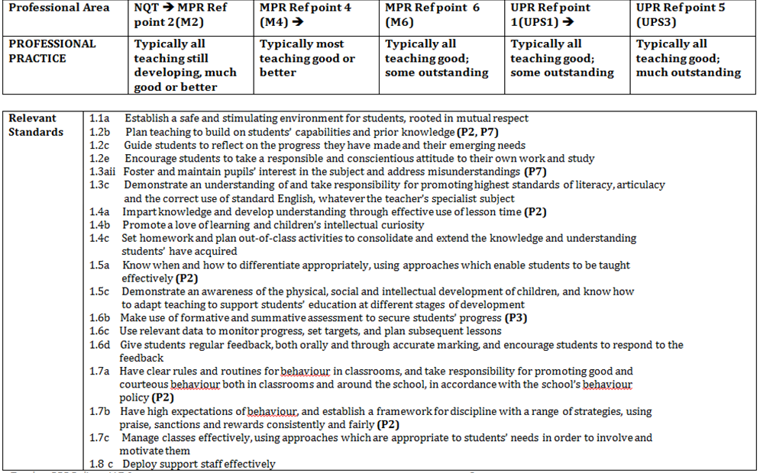
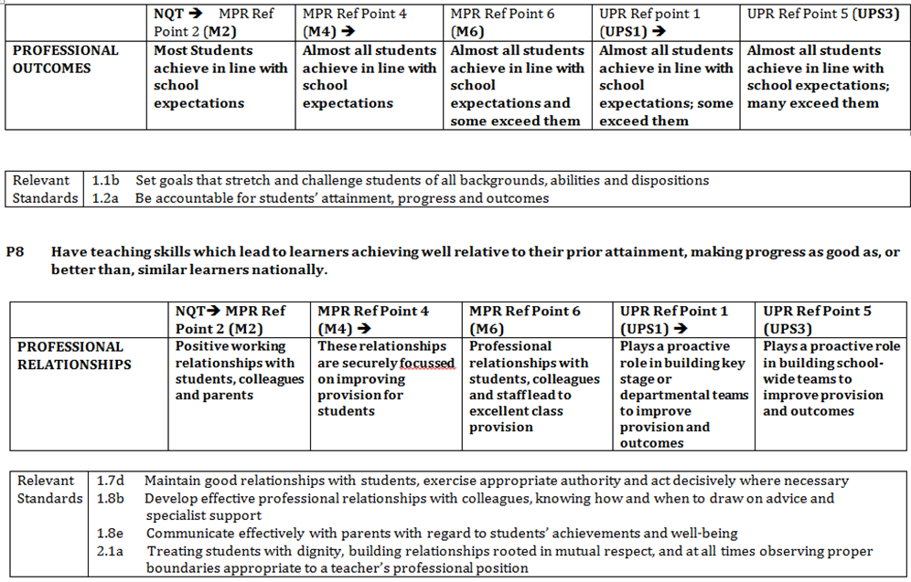
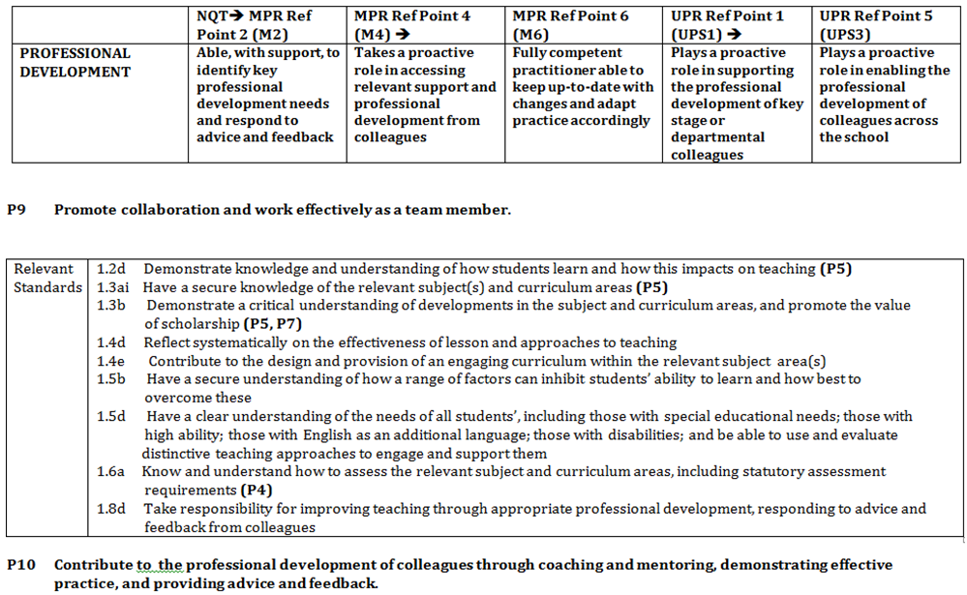
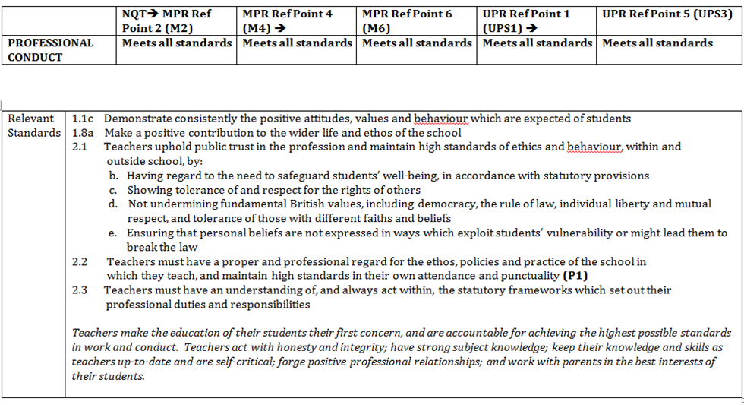

APPENDIX 4 – LAYERED OBJECTIVES
Please find below suggested examples of performance objectives for staff in different posts that link to overarching whole-school improvement objectives. In line with “Making Data Work” managers should ensure that not all objectives are data driven, data should be only part of the measure of success.
https://www.gov.uk/government/publications/teacher-workload-advisory-group-report-and-government-response
There is also suggested success criteria and monitoring arrangements for each performance objective set out for headteacher, deputy and middle leaders (subject leader/HOF) and classroom teachers related to the following overarching aims:
- Improving pupil progress and attainment
- Raising the quality of teaching
- Implementing a new behaviour for learning policy
The objectives suggested do not set out the support, training and resources required to enable an individual to meet them, nor do they include dates alongside the success criteria to provide milestones. These would need to be added in during the year, along with the details of any mid-year review process.
Whole-school objective: improving pupil progress and attainment
School improvement plan objective
To meet or exceed the school’s targets for pupil performance, where:
- X% of pupils in year 11 achieve 5+ 9 - 4 including English and maths
- The outcomes of groups of pupils, particularly those who have special educational needs (SEN) or disabilities, those for whom the pupil premium provides support, and the most able, meet or exceed the targets for each group
- X% of pupils in year 11 achieve the English Baccalaureate
- X% of pupils in year 11 make expected progress
- Across all years X% of pupils, including those who have SEN or disabilities, those for whom the pupil premium provides support, and the most able, are on track to make expected progress
Individual Performance objective for a headteacher
To secure or exceed the school’s targets for pupil performance in examinations at the end of year 11 and to ensure that across all years X% of pupils, including those with SEN or disabilities, those for whom the pupil premium provides support, and the most able, are on track to make expected progress.
To identify underachieving pupils and to put into place appropriate interventions.

Success criteria
- X% of pupils in year 11 achieve 5+ 9-4including English and maths
- The outcomes of groups of pupils, particularly those who have SEN or disabilities, those for whom the pupil premium provides support, and the most able, meet or exceed the targets for each group.
- X% of pupils in year 11 achieve the English Baccalaureate
- X% of pupils in year 11 make expected progress
- Across all years X% of pupils, including those who have SEN or disabilities, those for whom the pupil premium provides support, and the most able, are on track to make expected progress
Monitoring
- Data reports detailing progress against this objective and reporting the outcomes of the examinations, provided as part of the headteacher’s report to the governing body ahead of its meetings and reported to the appropriate sub-committee as required
- Progress reports provided to the school improvement partner when required
Individual Performance objective for a deputy headteacher
To work with the headteacher to secure or exceed the school’s targets for pupil performance in examinations at the end of year 11 and to ensure that across all years X% of pupils, including those with SEN or disabilities, those for whom the pupil premium provides support, and the most able, are on track to make expected progress. Specifically, to:
- Ensure that the revised tracking and data collection and reporting systems are in place, are functioning correctly, and are understood by all staff
- Ensure that the timetable of data entry by staff is adhered to
- Provide challenge and support to middle leaders where there are concerns about pupil progress
- Identify underachieving pupils and put appropriate interventions in place
- Brief the senior leadership team (SLT) and the appropriate governing body committee on the outcomes of each data entry cycle to facilitate response planning
Success criteria
- School targets are met or exceeded
- X% of pupils are on track to make expected progress
- Interventions are made where underachievement is identified, and impact positively on performance
- All data collection and reporting processes completed according to schedule
- Middle leaders challenged and supported where underachievement is identified
- New staff provided with training and support
- Reports made to governors and SLT
Monitoring
- Reports on progress made to SLT as per the SLT meeting schedule
- Review meetings with headteacher
- Update reports made at meetings of the governing body curriculum, teaching and learning committee, and to the full governing body if required
Individual Performance objective for a middle leader
To work with team members to implement strategies to secure improved pupil outcomes at the end of year 11, and to ensure that X% of pupils are on track to make expected progress.
Success criteria
- X% of pupils meet or exceed their targets for the end of year 11
- X% of pupils make expected progress by the end of year 11
- The outcomes of groups of pupils, particularly those with SEN or disabilities, those for whom the pupil premium provides support, and the most able, meet or exceed the targets for each group
- X% of pupils across the years are on track to make expected progress
- Interventions are made where underachievement is identified and impact positively on performance
Monitoring
- Monitoring meetings with SLT line manager, as per the schedule of line manager meetings, to review progress based on the latest data entries
- End of year 11 examination results
- Lesson observations and work scrutinies to identify whether or not pupils are making good or better progress
Individual Performance objective for teacher on main pay range (MPR)
To secure examination outcomes for year 11 class(es) that meet or exceed targets and to ensure that pupils taught across the years are on track to make expected progress in line with school expectations. This objective will need to be more specific to context and based on data held in a school
Success criteria
- X% of pupils in the class meet or exceed their year 11 examination outcome targets
- The outcomes of groups of pupils, particularly those with SEN or disabilities, those for whom the pupil premium provides support, and the most able, meet or exceed the targets for each group
- X% of other pupils taught are on track to make expected progress
Monitoring
- Examination outcomes for groups taught
- Outcomes for groups of pupils, particularly those with SEN or disabilities, those for whom the pupil premium provides support, and the most able
- Regular reviews of progress based on the monitoring of data entered into the school data system at regular intervals
- Evidence of good progress from lesson observations and work scrutinies
Whole-school objective: raising the quality of teaching
School improvement plan objective
To improve teaching so that X% of lessons are judged to be good or outstanding and none are judged to be inadequate.
Individual Performance objective for a headteacher
To secure further improvement in the quality of teaching so that X% of lessons are judged to be good or outstanding and none are judged to be inadequate.
Success criteria
- Staff training day focused on teaching that delivers clear impact
- Revised and clear procedures in place for working with staff whose teaching is judged to require improvement or to be inadequate
- Teachers whose teaching is judged to require improvement or to be inadequate make measurable progress, becoming good. Where inadequate progress is made, capability procedures are put in place
- The school’s observation, monitoring and review processes are understood and implemented fully and effectively by all senior and middle leaders
Monitoring
- Reports on progress against this objective provided to the full governing body and its committees as required
- Progress reports provided to the school improvement partner
Individual Performance objective for a deputy headteacher
To assist the headteacher in securing further improvement in the quality of teaching so that X% of lessons are judged to be good or outstanding and none are judged to be inadequate by:
- Planning and managing a whole-staff training day focused on improving the quality of teaching
- Ensuring that all subject leaders understand and implement the revised procedures for working with staff whose teaching is judged to require improvement or to be inadequate
- Ensuring that all subject leaders are fully and effectively implementing the school’s observation, monitoring and review processes
Success criteria
- Training day delivered with demonstrable positive impact on classroom practice
- Lesson observation data recorded centrally and reports prepared after each observation cycle
- Any teachers whose teaching is judged to require improvement or to be inadequate are supported and challenged appropriately by their team leader according to the revised procedures and make measurable progress becoming good, or otherwise are placed in capability procedures
- Middle leaders are held accountable for observation, monitoring, evaluation and review and know the processes in place for these. Any new middle leaders are mentored through the process by an experienced colleague
Monitoring
- Reports on progress made to SLT as per the SLT meeting schedule
- Review meetings with headteacher
- Update reports made at meetings of the governing body curriculum, teaching and learning committee, and to the full governing body if required
Individual Performance objective for a middle leader
To ensure a further improvement in teaching in the subject/faculty with at least X% of lessons being judged to be good or outstanding and none being judged to be inadequate.
Success criteria
- Structured and recorded follow-up discussions after the training day in team meetings, with ideas and strategies for improvement being shared and shaped by the team
- Impact and effectiveness of new strategies discussed, reviewed and recorded at team meetings
- Staff engaged in and committed to the improvement process
- Evidence of impact on the practice of those teachers whose teaching is judged to require improvement or to be inadequate
- All observation, monitoring, evaluation and review processes fully implemented
- Evidence of improving classroom practice in pupils’ work and lesson observation outcomes
- Parental and pupil feedback indicates improvements in teaching
Monitoring
- Reports to SLT line manager as per the schedule of line manager meetings
- Reports to the governing body’s curriculum, teaching and learning committee as required
- Work scrutinies and lesson observation outcomes
- Pupil and parent feedback
- SLT line manager attendance at selected team meetings
Individual Performance objective for teacher on upper pay range (UPR)
To support and develop other teaching staff to make clear progress in the quality of their teaching.
Success criteria
- All lessons by the staff being supported are judged to be at least good
- A percentage of their lessons judged to be outstanding
- Clear evidence of good and outstanding practice in pupils' work
Monitoring
- Lesson observation outcomes
- Work scrutinies
- Self-review
- Feedback from supported teachers
- Reports to the line managers of supported staff
- Reports to the member of the SLT responsible for staff development
The following objectives for a teacher on the main pay range (MPR) can also be used for a teacher on the UPR.
Individual Performance objective for teacher on main pay range (MPR)
All lessons observed to be good or better. (A percentage of lessons expected to be outstanding could be added where appropriate, as a challenging target for some staff.)
Success criteria
- All lessons observed judged to be at least good
- [If used, percentage of lessons judged to be outstanding]
- Clear evidence of effective practice in pupils’ work
- Pupils meeting or exceeding their targets
- Pupil and parent feedback indicates that teaching is at least good
Monitoring
- Lesson observation outcomes
- Work scrutinies
- Pupil outcomes
- Pupil and parent feedback
- Self-review
Whole-school objective: implementing a new behaviour for learning policy
School improvement plan objective
To introduce the new behaviour for learning policy and associated procedures.
Individual Performance objective for a headteacher
To oversee the successful implementation of the new behaviour for learning policy and its associated procedures.
Success criteria
- Staff training day delivered focused on new approaches to behaviour management and the processes to be followed
- The number of lessons judged to be good or better increases to X%, with none judged to be inadequate
- Data from lesson observations indicates effective implementation of the new policy and improved behaviour in classrooms
- X% reduction in fixed-term exclusions
- X% reduction in permanent exclusions and managed transfers
- X% reduction in the number of reported incidents of bullying
- Feedback from staff and pupil questionnaires reflects improved behaviour
- The new policy and procedures are understood and implemented fully and effectively by all senior and middle leaders
Monitoring
- Reports on progress against this objective, including numerical data for the success criteria, provided to the full governing body and its committees as required
- Progress reports provided to the school improvement partner
- Outcomes of policy review
Individual Performance objective for a deputy headteacher
To lead the successful implementation of the new behaviour for learning policy and its associated procedures.

Success criteria
- Training day delivered with positive feedback from staff evaluations and demonstrable positive impact on classroom practice
- Pastoral team leaders and subject leaders clear about their responsibilities for implementing the new policy and processes in their areas of responsibility
- The number of lessons judged to be good or better increases to X%, with none judged to be inadequate
- Data from lesson observations indicates effective implementation of the new policy and improved behaviour in classrooms
- X% reduction in fixed-term exclusions
- X% reduction in permanent exclusions and managed transfers
- X% reduction in the number of reported incidents of bullying
- Feedback from staff and pupil questionnaires reflects improved behaviour
Monitoring
- Reports on progress made to SLT as per the SLT meeting schedule
- Review meetings with headteacher
- Update reports made to the appropriate governing body subcommittees and to the full governing body if required
- Outcomes of policy review
Individual Performance objective for a middle leader
To ensure the effective implementation of the new behaviour for learning policy and associated procedures in the area of responsibility.
Success criteria
- Structured and recorded follow-up discussions after the training day in team meetings, with ideas and strategies for implementation being shared and shaped by the team
- Impact and effectiveness of new strategies discussed, reviewed and recorded at team meetings
- Staff engaged with and committed to the improvement process
- Evidence of improving classroom behaviour in pupils’ work and from lesson observations
- X% reduction of incidents in lessons requiring assistance from a colleague
- Parental and pupil feedback provides evidence of improvements in behaviour
Monitoring
- Reports to SLT line manager as per the schedule of line manager meetings
- Reports to the appropriate governing body committee as required
- Work scrutinies and lesson observation outcomes
- Pupil and parent feedback
- SLT line manager attendance at selected team meetings
- Outcomes of policy review
Individual Performance objective for teacher on main pay range (MPR)
To implement the new behaviour policy and procedures in all classes taught and in the tutor group.
Success criteria
- Clear evidence from lesson observations and scrutiny of pupils’ work that behaviour has improved
- Evidence from record keeping that the new processes are being effectively implemented
- X% reduction of recorded incidents in lessons
- The programme to inform tutor groups about the new policy is delivered effectively, with members of the tutor group being clear about the expectations and processes in the new policy
Monitoring
- Lesson observation outcomes
- Data on classroom incidents
- Work scrutinies
- Pupil and parent feedback
- Self-review

Version log
Version | Status | Date | Description of change | Reason for change | Pages affected
5.0 | Final |  | New format | New format | All
6.0 | Draft |  | Addition of appendix 3 -Layered objectives | Annual Review | 24-32
7.0 | Draft | 30/10/2018 | Added bullets to 3.1, 3.2 ,3.3 and section 7. Updated consultation log & amended policy review to annual. Added link to “Making Data Work” | Union feedback | 3,4,9,14
8.0 | Draft | 04/09/2019 | Added “Making Data Work” amendments from union meeting | Union feedback
9.0 | Draft | 10/09/2019 | Review as last years’ amendments were not given final sign off |  | All

