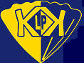
Kimbolton St. James’ C of E Primary School
Curriculum Map for Grammar and Punctuation
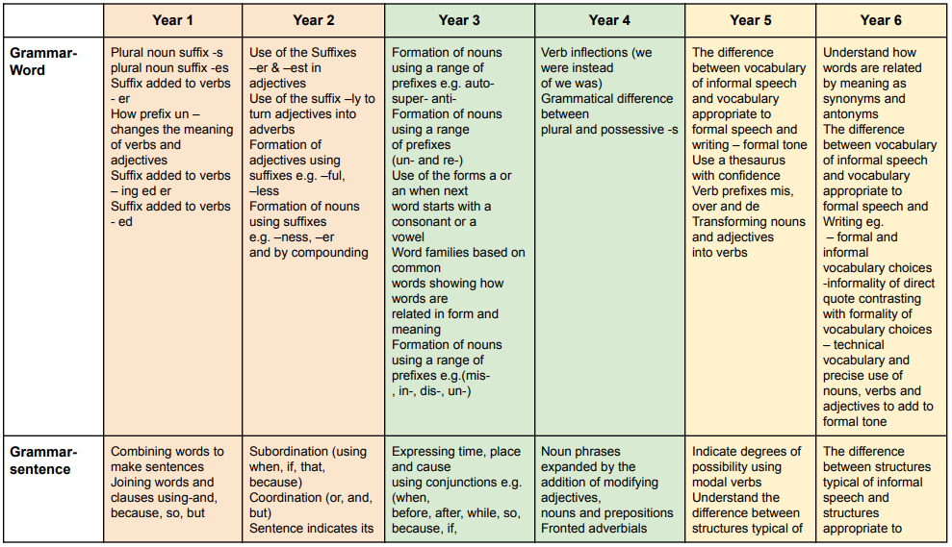
Kimbolton St. James’ C of E Primary School
Curriculum Map for Grammar and Punctuation
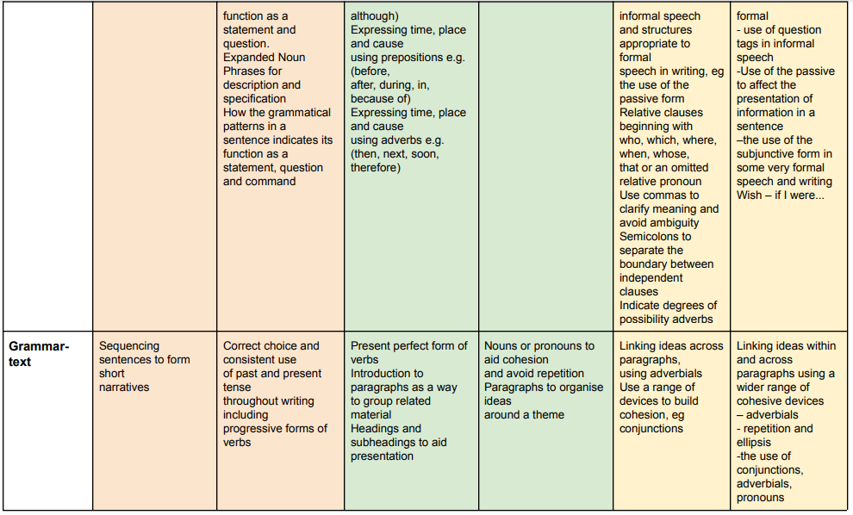
Kimbolton St. James’ C of E Primary School
Curriculum Map for Grammar and Punctuation
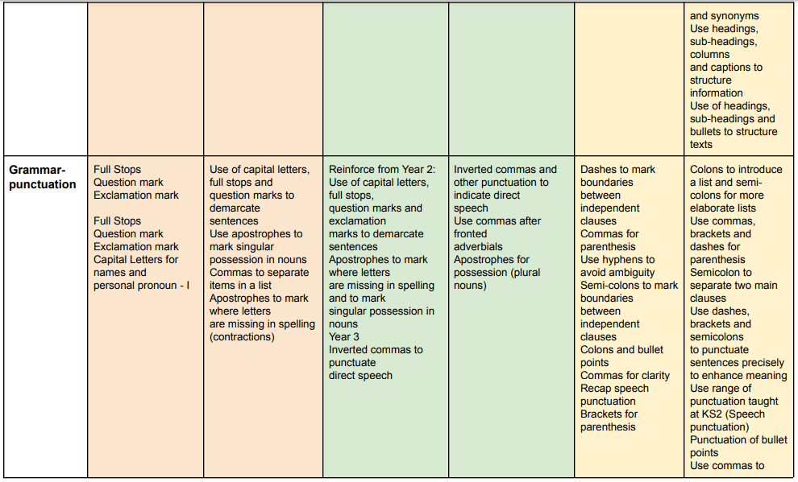
Kimbolton St. James’ C of E Primary School
Curriculum Map for Grammar and Punctuation
